**ASSINGMENT 4**

1. Create a new GitHub repository.

* Clone the repository to your local machine using SSH (generate an SSH key if needed, add the public key to your GitHub account).
* Create a new branch named after your username (e.g., Tutedude).
* Add your Flask project files to this branch.
* Commit the changes and merge the branch into the main branch.

Answer: - Clone the repository to your local machine using SSH (generate an SSH key if needed, add the public key to your GitHub account).

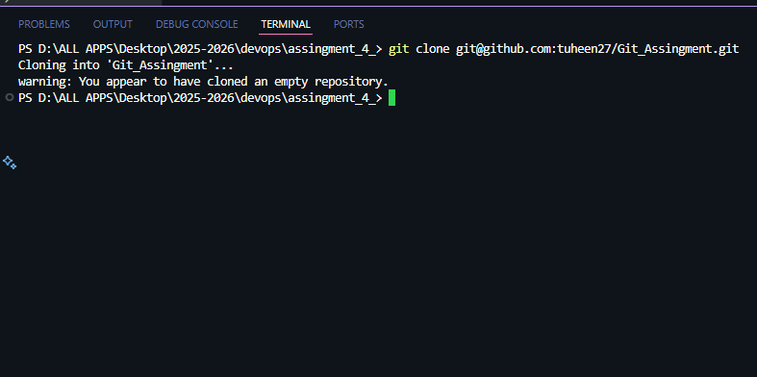

* Create a new branch named after your username (e.g., Tutedude).
* 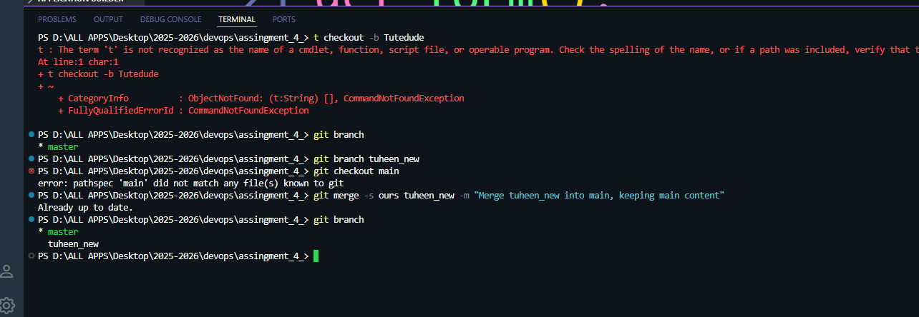
* Add your Flask project files to this branch.
* Add ..
* Commit the changes and merge the branch into the main branch.



2. Create new branch named <your name>

* Update the current of the json file used the /api route in this branch

Answer: -

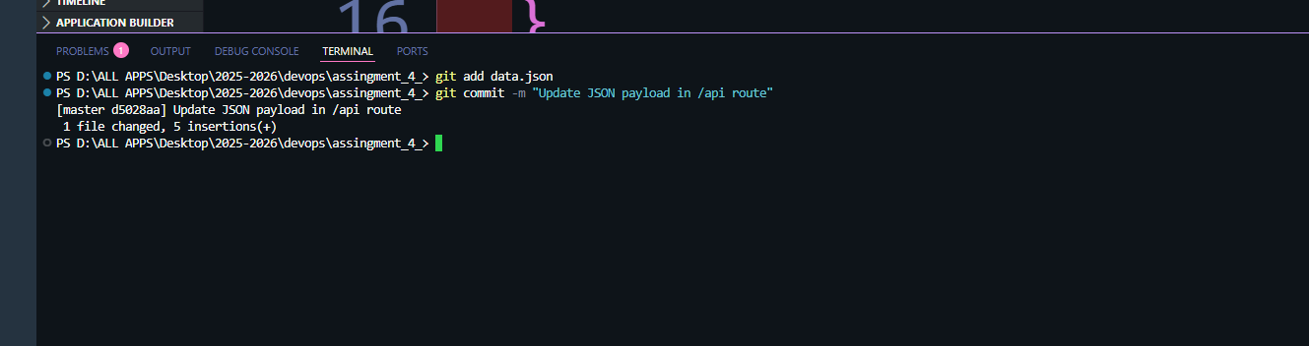

* Marge the <your_name> branch into

Answer: -



3. Branch creation

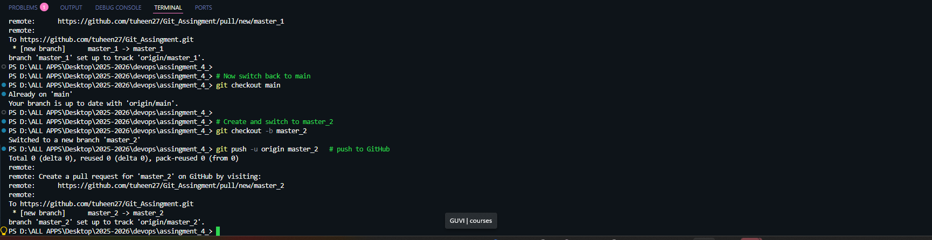

* Create two branches: master_1 and master_2 from the main branch.
* **Feature Development in** master_1:
* In the master_1 branch, create a **To-Do Page** in the frontend.
  + The page should contain a form with the following fields:
    - **Item Name**
    - **Item Description**
* **Backend API in** master_2:
* In the master_2 branch, create a backend route named /submittodoitem.
* This route will:
  + Accept itemName and itemDescription via a POST request.
  + Store these details in a MongoDB database.
* **Merging Changes**:
* Merge the changes from both master_1 and master_2 into the main branch.

